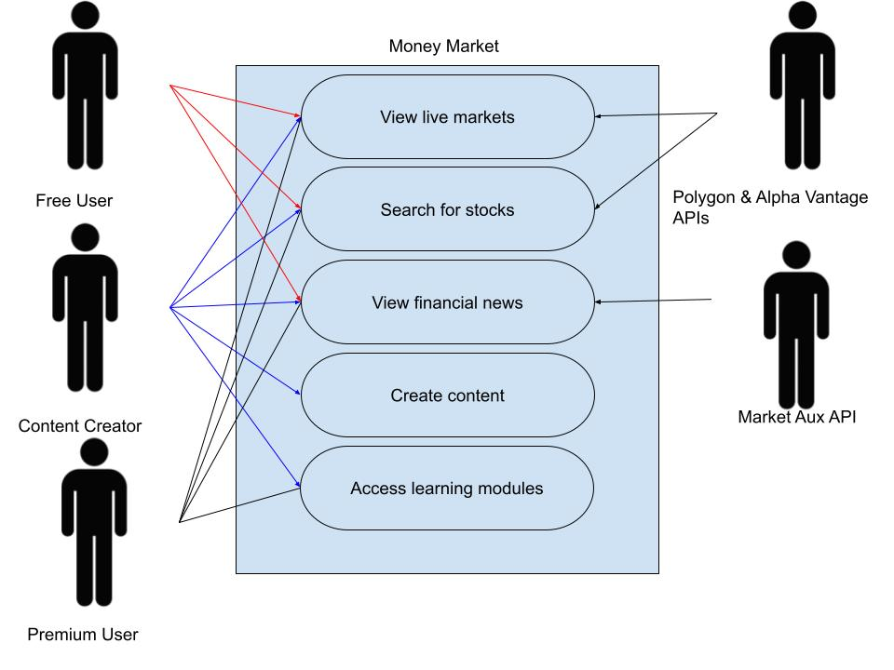

| **Use Case** | **Actors** | **Description** |
| --- | --- | --- |
| View live markets | Free user, Content Creator, Premium User | User can view live stock market data such as the share price, real time graphs, recent history, 52 week high/low, profit margin, operating margin, and P/E ratio. |
| Search for stocks | Free user, Content Creator, Premium User | User can search for information about any publicly traded stock on the market to view live data. |
| View financial news | Free user, Content Creator, Premium User | User can view recent financial news in real time that may have impacts on the market. |
| Create content | Content Creator | User can create learning series to allow other users to learn about investing. User can create, edit and delete learning pages. |
| Access learning modules | Premium User, Content Creator | User can access learning modules that provide instructional content about how to use and profit from the stock market. |

